Aubrey FFA 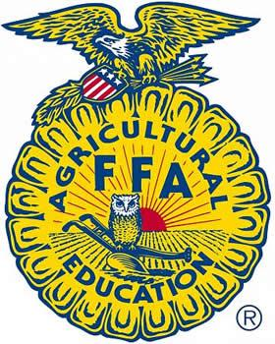
Awards Application 2023
Due Tuesday, April 11, 2023
Highlight ALL areas in which you are applying:

Outstanding 8th Grader Ambassador Award
Outstanding 9th Grader Top Hand Award (all grades eligible)
Outstanding 10th Grader Outstanding Officer
Outstanding 11th Grader
Outstanding 12th Grader
Outstanding Jr. Member (7th grade & younger)

Please identify the area below you have focused on.
Term: Production is the birth, raising, and feeding of an animal.
Term: Showmanship is being a quality showman
(the awards below are only for Sr. FFA members 8th - 12th-grade members)

Swine Production Cattle Production Goat Production
Swine Showmanship Cattle Showmanship GoatShowmanship Sheep Production Small Animal Production Public Speaking Sheep Showmanship Ag Mechanics
Poultry Production Tractor Driving
Diversified Livestock (multi-species)
Other Proficiency areas: __________________________

Please type the remaining portion of this application in great detail. In black font.
You are welcome to add pages and spaces to the following questions:

Name:_________________________________________

2022-23 Grade:____ How many years have you been a member?_______

List all the AG Classes have you taken if applicable.

Describe your current SAE Project (show project). What motivated you to begin? If this is not your first year, what have you learned that you do differently this year than in the previous year or when you started?

What were 2 or 3 goals you had when you started your SAE Project?

Describe your progress towards your goals.

What FFA activities did you participate in this year? List all. (place an X in the Chapter, District, Area or State box, in Achievements put your placings)

Year | Activity | Chapter | District | Area | State | Achievements
Why do you think you should receive this/these award(s)? Be detailed in your descriptions. You may add pages.

